Leap · PikPak
PikPak Fleet Database Plan
One company database in Azure to replace the spreadsheets: the fleet, customers, SKUs, trays, maintenance, issues and root causes, daily production, and the telemetry, with every change tracked and backups that look after themselves.
Draft for discussion · 7 September 2026
Prepared by Chris Hamblin. Read time about fifteen minutes. The decisions needed at the meeting are on the last page.

Summary
Today the fleet lives in spreadsheets: system serial numbers, customers, SKU numbers, tray numbers, maintenance events and root cause analyses, each in its own workbook, each with its own idea of a system's name. They are hard to join, hard to back up and impossible to audit.
This plan replaces them with one database in Azure. It is a PostgreSQL database, the same engine behind most modern web systems, run for us as a managed service so backups, patching and failover are Microsoft's job. A small internal web app is where people add and edit records, with Microsoft sign-in and a change history on every row. Excel, Power BI and Grafana read from it. The Logfather reads its master data from it and writes back what each system packed and which software it runs, without anyone typing.
The telemetry that Grafana shows today, component temperatures and motor currents, goes into the same database through the TimescaleDB extension, so a temperature excursion, the servo that was fitted at the time, and the issue it became are three tables apart, not three systems apart.
What we are asking for. Agreement on the eight areas and the tables in them, on the engine, and on the order of work. About thirteen weeks for one engineer, and Azure costs of roughly £100 a month.
What happens first. A one-week discovery to inventory the spreadsheets and name the data owners, then a two-day hands-on trial of the managed database before any real infrastructure is built.

How the system works
Three layers, each replaceable on its own.
- One database, the source of truth. Azure Database for PostgreSQL holds every record: the relational tables, JSON where a record is naturally a document, and the time series through TimescaleDB. Spreadsheets become read-only views of it, never the other way round.
- One entry app. A small internal web app for adding and editing records, with sign-in through the company Microsoft account, roles, and a full change history on every row. Phase one is a generated admin interface, not bespoke screens.
- Consumers. Excel and Power BI read from views with a read-only login. Grafana reads the telemetry tables directly. The Logfather reads customers, lines, systems and SKUs from the database, writes production and software history into it, and can raise an issue from its Errors / Stops window with the system and day filled in. LeapHQ, the customer portal being built separately, uses the same database for its customer-facing views and keeps reading Elastic and the CCTV share directly, as the Logfather does.
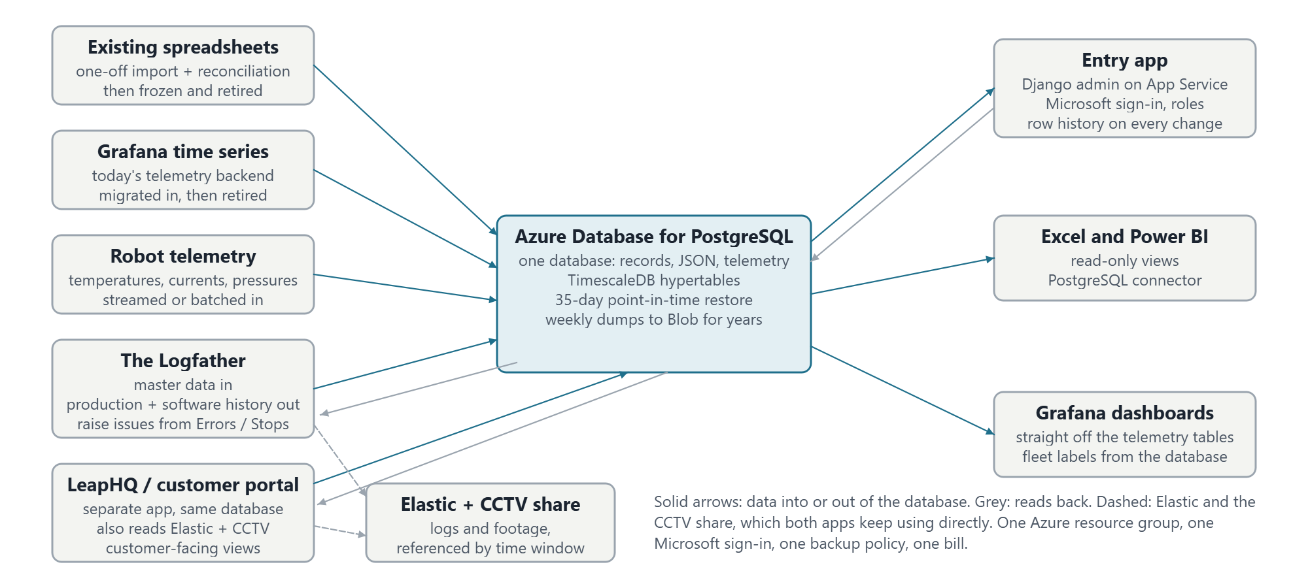

Trackable
Every table carries who created and last changed a row and when, and the entry app writes a history row for every change on the core tables. "What did this system's line assignment look like on 3 March" is a single query. Nothing is ever hard-deleted; rows are retired with an end date.

Easy to back up
The managed service takes automatic backups with point-in-time restore for up to 35 days, optionally copied to a second region. For years-long retention a weekly dump goes to Blob Storage with a lifecycle rule, one small scheduled job. A restore drill is a ticket in the plan, not an afterthought.

The engine
Decided: Azure Database for PostgreSQL Flexible Server, with the TimescaleDB extension, one database for everything.
Relational tables for the fleet, JSON columns where a record is naturally a document, and TimescaleDB hypertables for the telemetry, all under one backup, one sign-in and one connection string. Django speaks PostgreSQL natively, Grafana has a first-class PostgreSQL data source, and Excel and Power BI connect through the PostgreSQL connector.
What we give up against Azure SQL: built-in temporal tables (row history comes from the app instead), the Excel SQL Server connector people have seen before (the PostgreSQL one needs a one-time driver install), and built-in long-term backup retention (a weekly dump covers it). What we gain: no second store for telemetry, no cross-store joins, and a smaller bill.
Not recommended: Dataverse or SharePoint lists (licensing per user, weak relational model, hard to query from outside), a separate NoSQL store (this is relational data with many-to-one links everywhere), or a separate time-series service now that Timescale lives inside the same database.

The eight areas
The system table is the hub; every other area attaches to it or to customer. Each area is a box below.
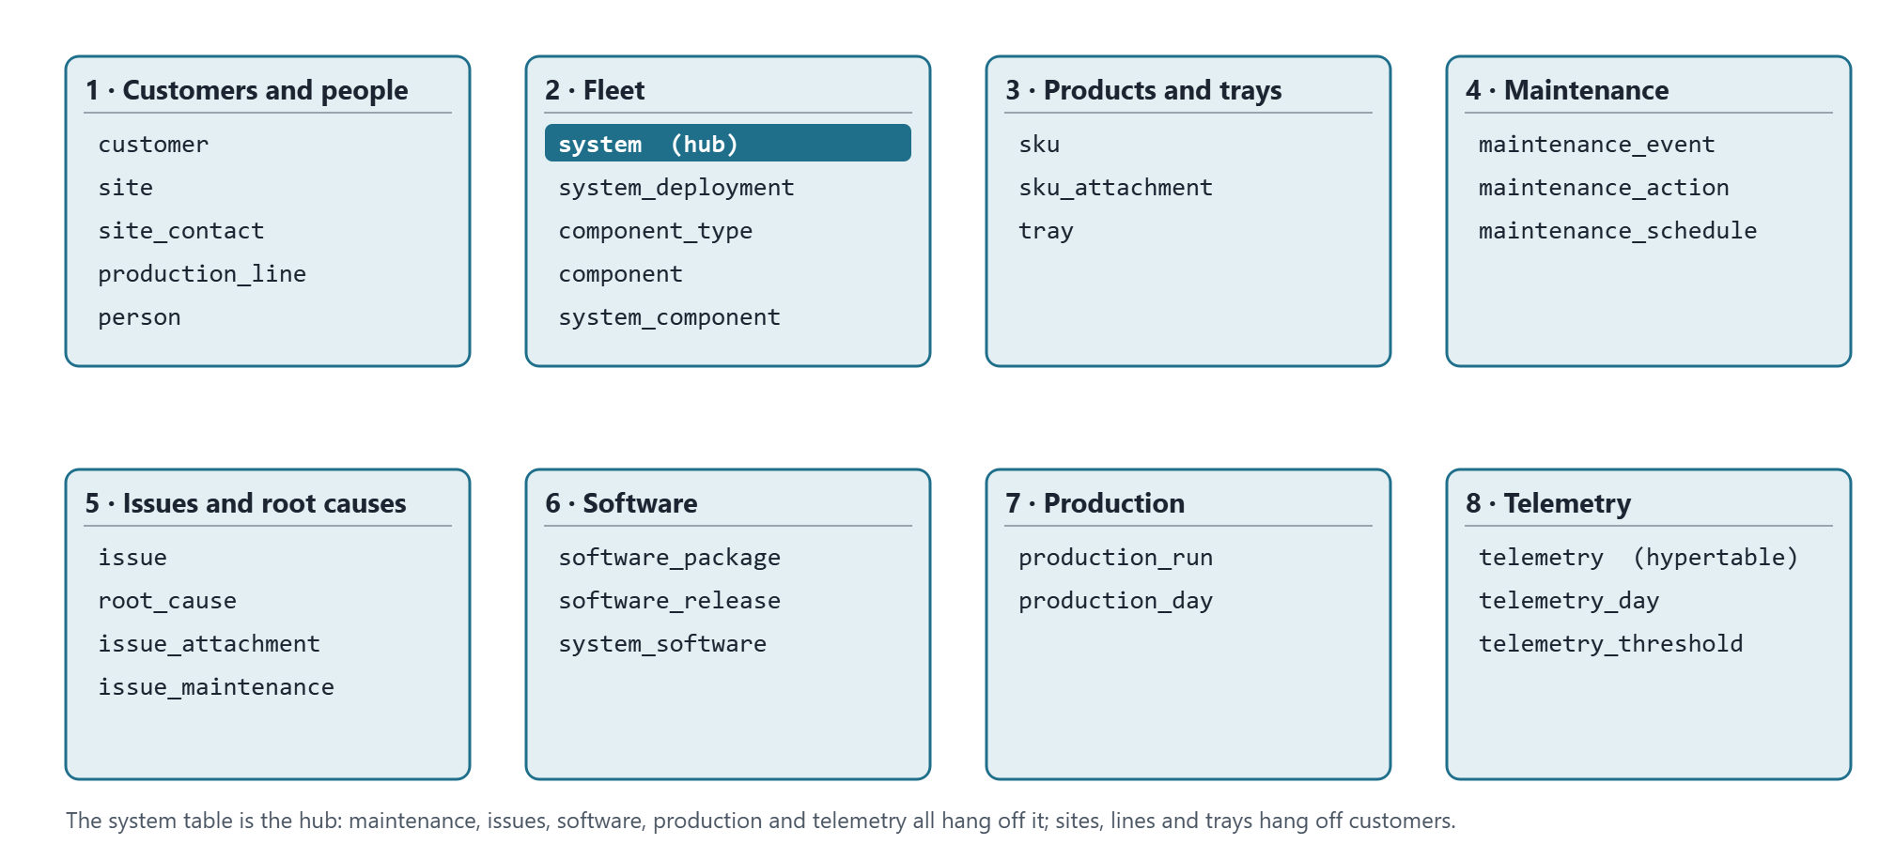
Area | Tables | What it answers
1 · Customers and people | customer, site, site_contact, production_line, person | Who our customers are, where their sites and lines are, who to call.
2 · Fleet | system, system_deployment, component_type, component, system_component | Every PikPak, where it is and was, what is fitted in it.
3 · Products and trays | sku, sku_attachment, tray | Every product line, its pictures, and the tray it is packed in. A SKU is the same wherever it is packed, so it belongs to no one customer.
4 · Maintenance | maintenance_event, maintenance_action, maintenance_schedule | What was done to each system, by whom, and what is due.
5 · Issues and root causes | issue, root_cause, issue_attachment, issue_maintenance | What went wrong, why, and what fixed it.
6 · Software | software_package, software_release, system_software | Which release each system runs and which are approved.
7 · Production | production_run, production_day | Which SKU went into which tray on which system on which day, and how many. Fed from Elastic, not typed.
8 · Telemetry | telemetry, telemetry_day, telemetry_threshold | Every temperature, current and pressure reading, and the daily summary per component that issues and maintenance planning use.

Keys and conventions
- Surrogate primary keys everywhere: an integer id per table. Serial numbers, tray numbers and SKU codes are human identifiers that get retyped and corrected, so they must not be what other tables point at.
- Natural keys as unique constraints: a system's serial number (with the display name "PikPak 007" unique too, but only ever a label), a tray's unique number, a SKU's code, a package's git commit. Duplicates are rejected by the database.
- Human references on things people talk about: ISS-0001, MNT-0001, RC-0001, generated from the id and shown everywhere.
- History as date ranges, not overwrites. Where a system is, which component is fitted, which software runs: each is a row with from and to dates, and only one open row is allowed per subject.
- Lookups are tables, not free text: statuses, severities, event types, component types and issue categories, so a new value is a row, not a code change.
- Audit on every table plus a history table per core entity, giving the same "as of" queries a temporal table would.
- Time series are hypertables: partitioned by time automatically, compressed after 30 days, kept for years.

The tables
Key: the primary key, then the unique or natural key in brackets. Columns lists the ones worth arguing about; audit columns are on every table.

1 · Customers and people
Table | Key | Columns worth naming
customer | customer_id (name) | short_code (EVG, LWS), status, account owner, notes
site | site_id (customer_id, name) | address, timezone, notes
site_contact | site_contact_id (site_id, person_id, role) | The customer's people at a site: person, role (production manager, maintenance lead, IT, quality, commercial), is_primary, phone / email overrides, active_from, active_to. A person can hold roles at several sites.
production_line | line_id (site_id, name) | name ("Line 6"), description, shift pattern
person | person_id (email) | name, phone, organisation (own / customer / contractor), customer_id when they belong to a customer, job title, active. Used by contacts, maintenance and issues alike.

2 · Fleet
Table | Key | Columns worth naming
system | system_id (serial_number; display_name; folder_name) | The serial number "35-2300-007" is the identity; display_name "PikPak 007" is what every screen shows; folder_name "PikPak007" is the CCTV share folder, kept separate so a rename never breaks the footage path. Plus generation (Argus 1 / 2), build_date, status (in build, FAT, installed, workshop, decommissioned), notes.
system_deployment | deployment_id (one open row per system) | system, line, installed_on, removed_on, reason. Answers "where was PikPak 007 in March".
component_type | component_type_id (name) | servo, drive, camera, PSU, IO card, PC, gripper, conveyor motor
component | component_id (serial_number; part_number) | type, supplier, purchased_on, warranty_until, status
system_component | system_component_id (one open row per system + position) | system, component, position ("servo 2", "pick camera"), fitted_on, removed_on, the maintenance event that fitted it. Telemetry joins to this row, so a reading is attributed to the exact servo in that slot at the time.

3 · Products and trays
No tray-type table: most trays are unique with subtle differences, so the design lives on the tray. No recipe-version table: a SKU never changes once defined and is the same for every customer that packs it.
Table | Key | Columns worth naming
tray | tray_id (unique_number) | dimensions, cavity layout, material, supplier, drawing reference; customer, site, status (in service, damaged, retired), commissioned_on, retired_on. A damaged tray is an issue with the tray linked, not a separate log.
sku | sku_id (code) | code as logged in Elastic ("EVG_picc…"), description, product dimensions and weight, products per pick, the tray it is packed in, config (JSON, the recipe), status. Not owned by a customer.
sku_attachment | attachment_id | sku, kind (photo, drawing, spec sheet), file in Blob Storage, caption, sort order, uploaded by. One SKU can carry several pictures.

4 · Maintenance
Table | Key | Columns worth naming
maintenance_event | event_id (MNT-0001) | system, type (planned service, breakdown, part replacement, software update, calibration, inspection, FAT), started_at, ended_at, downtime_minutes, performed_by, summary, external ticket
maintenance_action | action_id | event, description, component removed, component fitted, labour hours, parts cost
maintenance_schedule | schedule_id (system_id, task) | task, interval (days or picks), last done, next due. Optional in phase one.

5 · Issues and root causes
Kept deliberately simple: a root cause is an entry in a catalogue with its own number, and an issue points at one. No workflow states, no analysis records; those can be added later.
Table | Key | Columns worth naming
root_cause | root_cause_id (RC-0001; name) | The catalogue of every known root cause: name ("Vacuum solenoid stuck"), description, category (mechanical, electrical, software, operator, product, tray, environment), active. Never deleted, only retired.
issue | issue_id (ISS-0001) | system (nullable for site-level), site, tray (nullable), reported_at, reported_by, title, description, severity, root cause (nullable until known), Grafana link, Jira key, notes
issue_attachment | attachment_id | issue, kind (photo, clip, log export, document), file, caption, uploaded by
issue_maintenance | (issue_id, event_id) | links an issue to the maintenance that fixed it

6 · Software
Table | Key | Columns worth naming
software_package | package_id (name) | argus, planner, targeting, actuators, sensors, infeed, crate_change, behaviour, firmware packages
software_release | release_id (package_id, git_commit) | version, branch, released_on, approved, release notes. Where "which commits are approved for the fleet" lives.
system_software | system_software_id (one open row per system + package) | system, package, release, installed_at, removed_at, source (manual / Elastic). The Logfather already computes this from Elastic.

7 · Production
Nobody types this: the Logfather reads runs, SKUs and the pick-and-place counters from Elastic and writes them here nightly.
Table | Key | Columns worth naming
production_run | run_id (elastic_run_id) | system, SKU, tray, started_at, ended_at, products_packed, trays_packed, products_seen, products_rejected, pick_movements, raw counters (JSON), source. One row per run.
production_day | production_day_id (system, day, sku, tray) | The daily roll-up: products_packed, trays_packed, products_rejected, pick_movements, run_count, minutes_running, minutes_on. The table reports and Excel use.

8 · Telemetry
Raw readings and their daily summary live in the same database as everything else. The raw table is a TimescaleDB hypertable: an ordinary table partitioned by time behind the scenes, compressed after 30 days, with old chunks dropped past the retention we set.
Table | Key | Columns worth naming
telemetry | (time, system_id, position, metric) | time, system, position ("servo 2", "brake resistor", "PSU 48V"), metric (temperature, current, voltage, pressure, vacuum), value, unit, source. Compression after 30 days; retention 5 years; indexed so one servo's panel is instant.
telemetry_day | (system_id, position, metric, day) | the fitted component that day, min, average, max, minutes above threshold, threshold used, sample count. A continuous aggregate refreshed nightly; the table issues and maintenance planning read.
telemetry_threshold | (component_type_id, metric) | warning and alarm levels per component type and metric, so "minutes above threshold" changes with a row edit, not a code change.

Views for Excel, Power BI and Grafana
v_fleet_current, v_site_contacts, v_system_components_current, v_maintenance_log, v_issue_register, v_software_current, v_production_day, v_telemetry_day and v_telemetry_labelled: one read-only view per question people ask today, granted to the viewer role only.

The plan
Ten epics, fifty-five tickets, in dependency order. Estimates are working days for one person. Every ticket has acceptance criteria so it can be closed without discussion; the full text is in the working plan, this is the shape.

Epic 0 · Discovery and decisions (1 week)
ID | Ticket | Days | Done when
DB-001 | Inventory every spreadsheet: owner, rows, update frequency, which entity | 2 | One-page inventory in the repo
DB-002 | Name the data owners and the roles (admin, engineer, service, viewer) | 1 | Roles table with permissions per entity
DB-003 | Decision record: hosting, region, naming (engine already decided) | 1 | Short ADR in the repo
DB-004 | Agree identifiers: serial format, tray numbers, SKU code source, ISS / MNT / RC | 1 | Conventions signed off

Epic 0.5 · Hands-on trial of the managed PostgreSQL (2 to 3 days)
ID | Ticket | Days | Done when
DB-005 | Create a trial server in the portal, Burstable tier, Entra sign-in, Timescale enabled | 0.5 | SELECT version() runs
DB-006 | Connect from pgAdmin; run the trial script: two fleet tables, a telemetry hypertable, four real systems | 0.5 | Rows return; duplicate placement refused
DB-007 | Read it from Excel, Grafana and Python | 0.5 | All three show the same rows
DB-008 | Delete a row, restore to a point in time; dump and restore | 0.5 | Both restores succeed, steps written up
DB-009 | Tear down; three lines on what was easy and awkward | 0.5 | Cost page shows pennies

Epic 1 · Azure foundation (1 week)
ID | Ticket | Days | Done when
DB-010 | Infrastructure as code (Bicep): server, storage, Key Vault, App Service, logging; dev and prod | 2 | Clean deploy produces both
DB-011 | PostgreSQL server with Timescale, 35-day point-in-time restore, weekly dump to Blob kept 7 years | 1 | Restore and dump both verified
DB-012 | Entra sign-in mapped to database roles; managed identity for the app; no shared passwords | 1 | A viewer queries from Excel with Microsoft login only
DB-013 | Firewall, budget alert at £100 / month, log retention | 1 | Alert fires on a test
DB-014 | Blob containers for photos, clips, documents, dumps with lifecycle rules | 0.5 | Upload and cool-tier move seen

Epic 2 · Schema v1 (1.5 weeks)
ID | Ticket | Days | Done when
DB-020 | Migration tooling: Django models are the definition; CI applies migrations to dev | 1 | Merge to main migrates dev
DB-021 | Lookup tables seeded from the spreadsheets' real values | 1
DB-022 | Customers, sites, contacts, lines, systems, deployments, people | 1 | One open placement per system enforced
DB-023 | Component types, components, fitted history | 1
DB-024 | Trays, SKUs, SKU pictures | 1
DB-025 | Maintenance events, actions, schedule | 1
DB-026 | Root cause catalogue, issues, attachments, links to maintenance | 1 | Catalogue seeded from known causes
DB-027 | Software packages, releases, system software | 0.5
DB-027a | Production runs and days | 0.5
DB-028 | Row history and audit columns on the core tables | 1 | "As of" a date returns the old row
DB-029 | Reporting views, viewer role only | 1

Epic 3 · Data migration (1.5 weeks)
ID | Ticket | Days | Done when
DB-030 | Column mapping per sheet | 2 | Every source column has a target or a reason
DB-031 | Idempotent import scripts with a validation report | 3 | Every rejection has an owner
DB-032 | Reconciliation against the spreadsheets, signed off per owner | 1 | Counts match
DB-033 | Backfill systems, SKUs and software history from Elastic | 2

Epic 4 · Entry app (2.5 weeks)
ID | Ticket | Days | Done when
DB-040 | Django on App Service, Entra sign-in, managed identity, CI deploy | 2 | Health endpoint green
DB-041 | Screens: customers, sites with contacts, lines, systems, deployments, components, people | 2 | Search by serial; history per record
DB-042 | Screens: SKUs with pictures, trays with bulk number import | 1
DB-043 | Screens: maintenance with component swap picker | 2 | Swap closes old fitting, opens new
DB-044 | Screens: issues with attachments, root cause picker, counts per cause | 2
DB-045 | Roles and permissions from Entra groups | 1
DB-046 | Read-only JSON API for the Logfather and future tools | 1

Epic 5 · Excel and Power BI (0.5 week)
ID | Ticket | Days | Done when
DB-050 | Excel templates on the views, one per old spreadsheet, refresh on open | 1
DB-051 | Power BI fleet dashboard: fleet by customer, open issues, downtime, software coverage | 2

Epic 6 · Logfather integration (1.5 weeks)
ID | Ticket | Days | Done when
DB-060 | Master data from the database replaces the settings file; Software window flags unapproved commits | 2
DB-061 | "Raise issue" from Errors / Stops, pre-filled with system, day, CCTV and Grafana links | 2
DB-063 | Nightly production sync from Elastic into runs and days; back-fill since March 2022 | 3 | Day totals match the Overview within 1%
DB-062 | Nightly software history sync | 1

Epic 8 · Telemetry (2 weeks, after Epic 4)
ID | Ticket | Days | Done when
DB-080 | Where does Grafana read from today: backend, retention, metrics and units | 1 | Metrics inventory
DB-081 | Hypertable, compression, retention, thresholds | 1 | A year for one servo queries in a second
DB-082 | Ingestion from the existing backend, batched; back-fill what exists | 3 | Last week matches Grafana's graph
DB-083 | Labelled view joining readings to system, customer and fitted component | 1
DB-084 | Grafana on the database; dashboards re-pointed with fleet variables | 2
DB-085 | Daily summaries as a continuous aggregate | 2 | Known hot day matches raw data
DB-086 | Telemetry on issues: link and that day's summary rows | 1

Epic 7 · Operations and cutover (1 week)
ID | Ticket | Days | Done when
DB-070 | Restore drill and runbook | 1 | Point-in-time and dump restores done by someone else
DB-071 | Monitoring and alerts | 0.5
DB-072 | Training and a two-week parallel run with the spreadsheets frozen | 2
DB-073 | Retire the spreadsheets; Excel templates replace them | 0.5

Cost and timeline
Per month | What
£15–45 | PostgreSQL Flexible Server, Burstable tier for dev and prod, 64 GB, backups included
£12 | App Service B1 for the entry app and the sync jobs
£2–8 | Blob Storage including weekly dumps, Key Vault, Log Analytics
+£10–40 | once telemetry lands: storage growth and a step up to a General Purpose tier if ingest needs it
Everything together stays around £100 a month, which is the budget alert in the plan. The largest cost is people, not Azure: about thirteen weeks for one engineer, with the Excel, Logfather and telemetry epics able to overlap.

Order of value
After the schema and the fleet part of the migration, the database already answers the questions the spreadsheets cannot: where each system is and was, what is fitted in it, and what it runs. Issues and the root cause catalogue are the next most valuable and the most used day to day. Production and telemetry follow, fed by jobs rather than typing.

Risks
- Spreadsheet data that does not reconcile: the reconciliation ticket exists for this, and each data owner signs off their entity.
- Two sources of truth during the parallel run: the spreadsheets are frozen read-only for those two weeks.
- Microsoft group management landing with nobody: an owner is named in the roles ticket.
- Telemetry volume outgrowing the burstable tier: CPU is monitored, and the step up is a portal change, not a migration.
- Building bespoke screens before the generated admin has been used for a month: resist it.

Decisions needed at the meeting
- The eight areas and their tables. Anything missing, anything that should not be there. Recent simplifications to confirm: no tray-type table, no SKU recipe versions, SKUs not owned by customers, root causes as a numbered catalogue, damaged trays as issues.
- The engine. PostgreSQL with TimescaleDB, one database for records and telemetry, in place of Azure SQL plus a separate time-series service.
- Data owners. A name against each area for the inventory, the reconciliation and the sign-off.
- Roles. Who may create systems, close issues, approve releases; who is read-only.
- Identifiers. Serial-number format, tray numbering, that SKU codes come from Elastic's SKU name, and the ISS / MNT / RC reference scheme.
- Where Grafana reads from today, its retention and how far back data still exists, since that decides how telemetry gets in.

Next steps
- This week: the spreadsheet inventory (DB-001) and the Grafana backend question (DB-080) need nothing but time.
- Next week: the hands-on trial (DB-005 to DB-009), half a day each, with a written note at the end.
- Then Epic 1, once the decision record is signed.

